CPSC 614 Term Project: Cost-Sensitive Cache Replacement

Olusegun Adekile, Jongyoon Choi
Department of Computer Science
Texas A&M University
College Station, TX 77843
{segunad, goonyong}@tamu.edu

PAPER CITATION
J. Jeong and M. Dubois, "Cost-Sensitive Cache Replacement," Proceedings of the Symposium on High-Performance Computer Architecture (HPCA 03), February 2003.

ABSTRACT
We implemented the paper above, namely three cost-sensitive cache replacement algorithms which are extensions of the LRU. Cache replacement algorithms aim to reduce aggregate miss cost and execution time by factoring in a prediction of block miss costs as well as block locality in making a replacement decision. A performance analysis of all three cache replacement algorithms were done and compared with LRU with simple cost concept. The three algorithms are Basic (BCL), Dynamic (DCL) and Adaptive (ACL) Cost-sensitive LRU Algorithm. BCL and DCL use a greedy approach in reserving high cost blocks whilst ACL stores a history of cost savings and uses an adaptive reservation activation scheme.

KEYWORDS
Cache Replacement, LRU, BCL, DCL, ACL, Cost, Simple Scalar

1. Introduction
The most common cache replacement policy is choosing the least recently used block and it tries to reduce memory access latency. However different costs maybe possible to arise from cache miss in modern computer architecture. In case of embedded system, power consumption is the most important than performance. Also for the mission critical system, reliability may the key success factor. The cost may be various such as latency, penalty, power consumption, bandwidth consumption, or any other ad-hoc numerical property attached to a miss. In many practical situations, it is desirable to inject the cost of a miss into the replacement policy.
On referenced paper, the author tired to propose several extensions of LRU which account for non-uniform miss costs and explored the simple case of two static miss costs using trace-driven simulations to understand when cost-sensitive replacements are effective with CC-NUMA architecture. They applied the algorithms to the second-level cache of a multiprocessor with superscalar processors, using the miss latency as the cost function. In this report, we made similar simulation environments with Simplescalar-3.0. Although it is based on single CPU architecture, it emulates well the different replacement policies.
In chapter 2, we will enumerate the related replacement policies like LRU, GD (Greedy Dual), LRU with cost consideration, BCL (Basic Cost-sensitive LRU), DCL (Dynamic Cost-sensitive LRU), and ACL (Adaptive Cost-sensitive LRU). The chapter 3 will show the concept of cost used. In chapter 4, there will be the explanation about our implementation with Simplescalar-3.0. Also the differences from benchmark will be discussed on chapter 5.

2. Replacement Policy
2.1 Greedy Dual and LRU
LRU policy is one of the most common replacement policies. The definition in TehFreeDictionary.com is “A rule used in a paging system which selects a page to be paged out if it has been used (read or written) less recently than any other page. The same rule may also be used in a cache to select which cache entry to flush.” In case of cache, we expect to minimize miss rate from LRU. The following figure1 shows the example of LRU.
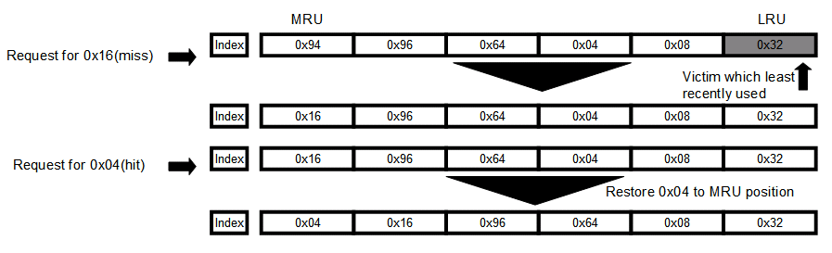
Figure 1. Least Recently Used (LRU) Replacement Policy
Greedy Dual only considers the cost and each block in a cache set is associated with its miss cost. When a block is replaced, the costs of all blocks remaining in the set are deduced by the current cost of the victim. Whenever a block is accessed, its original cost is restored. The block with lowest cost is always replaced. The figure 2 shows the GD example.
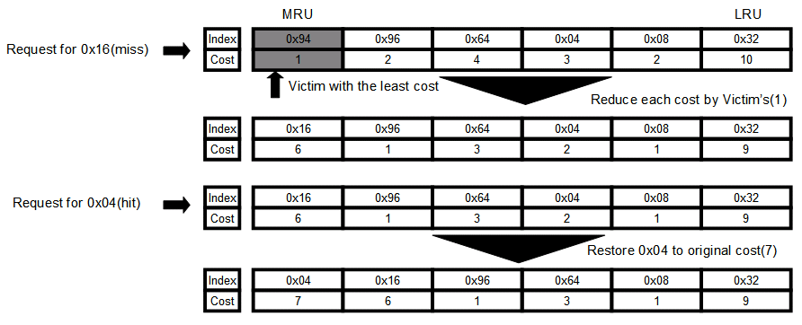
Figure 2. Greedy Dual Replacement Policy

2.2 LRU-based Cost-sensitive Replacement Algorithm
GD considers the only cost and LRU considers the only locality for choosing victim block. We could mix up both policy so called cost-sensitive LRU replacement algorithms to reduce the aggregate miss cost effectively must factor in locality.
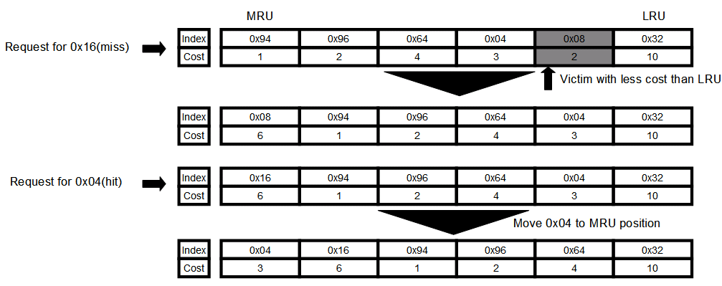
Figure 3. Cost sensitive LRU
In this policy at figure 3, we must replace the LRU block if the cost of the next miss to it is no greater than the cost of the next miss to any other block in the same set. We select the first block in the LRU stack order whose cost is lower than the cost of the reserved block.

2.3 Basic Cost-sensitive LRU Algorithm (BCL)
In the basic cost-sensitive LRU algorithm (BCL), we deduce the cost of a reserved LRU block whenever a higher locality) block is replaced in its place. When multiple reservations are active, BCL only depreciates the cost of the reserved block in the LRU position. The block in the LRU position has cost called Acost. Whenever a block is located at the LRU position, Acost is loaded as the miss cost of the new LRU block.
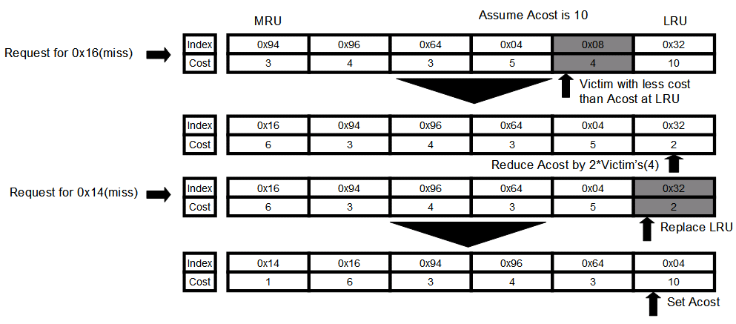
Figure 4. Basic cost sensitive LRU
To select a victim, BCL searches for the block position in the LRU stack with less cost than Acost and depreciate Acost by twice the amount of the miss cost of the replaced block. Otherwise, the LRU block is replaced.

2.4 Dynamic Cost-sensitive LRU Algorithm (DCL)
In DCL, the cost of a reserved LRU block is deduced only when the non-LRU blocks replaced are actually accessed before the reserved LRU block is. DCL records every replaced non-LRU blocks in a directory called the Extended Tag Directory (ETD). If an access misses in the cache but hits in ETD, then the cost of the reserved LRU block in the cache is reduced as in BCL and the matching ETD entry is invalidated. When an access hits on the LRU block, all ETD entries are invalidated.
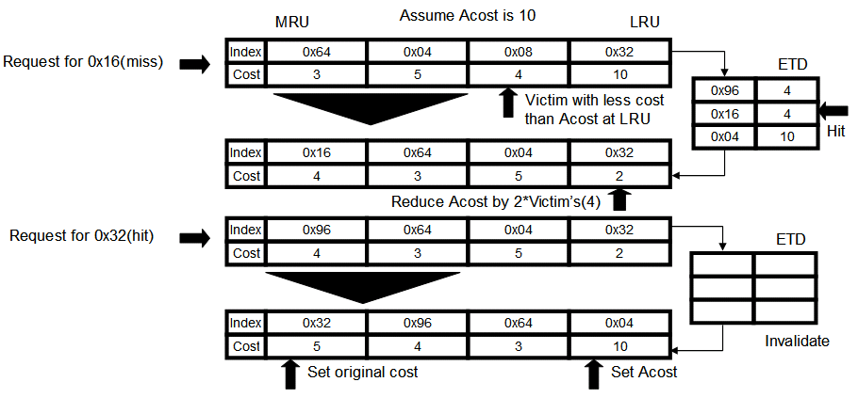
Figure 5. Dynamic Cost-sensitive LRU

2.5 Adaptive Cost-sensitive LRU Algorithm (ACL)
The adaptive cost-sensitive LRU algorithm (ACL) implements an adaptive reservation activation scheme exploiting the history of cost savings in each set. It associate a counter in each cache set to enable and disable reservations. The counter increments or decrements whenever a reservation succeeds or fails, respectively. When the counter value is greater than zero, reservations are enabled.
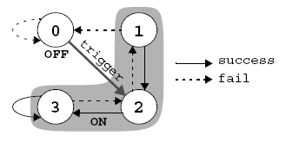
Figure 6. Counter on ACL
When reservations are disabled, an LRU block enters the ETD upon replacement if another block in the set has lower cost. Upon a hit in ETD, all ETD entries are invalidated, and reservations are enabled by setting the counter value to two.
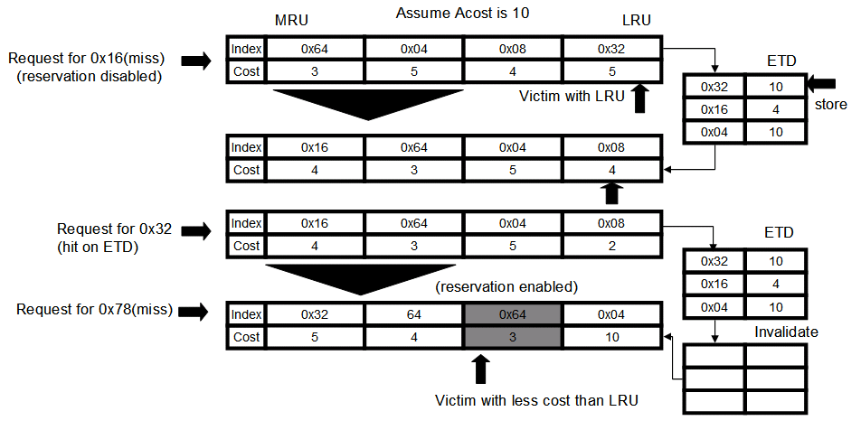
Figure 7. Adaptive Cost-sensitive LRU

3. Cost Definition
One of the most difficult problems on replacement policies is defining the proper cost. The referenced paper uses the miss latency as cost. Although you have straightforward concept of the cost, having the proper cost value is not an easy work. The author choose the cost for each block by pure physical address mapping in main memory and this mapping does not change during the entire execution.
There is two different mapping in this paper. The first one is Random Cost Mapping but it is not truly realistic and the author uses it to verify the high-cost access fraction. The random mapping distributes cost across block addresses thus low-cost and high-cost blocks are homogeneously spread in time and across cache sets. To make more realistic, they uses First-Touch Cost Mapping on which cost distribute highly correlated way. On our simulation, we follow the First-Touch Cost Mapping and assume that cost increases by each 256 * block size bytes. We assume the increasing cost by distance.

4. Implementation
4.1 Runtime structure
The Simple Scalar uses linked list to hold cache set. When the cache is accessed, the most recent block is located on the head on the list. If there is missing, it simply drop the tail and add new one to head. For GD, we compared the entire node from head to tail by cost. In case of cost sensitive LRU, we selects tail for LRU block. Then it tries to find higher cost than LRU from the head. If found one, it tries to find victim from the next to tail.
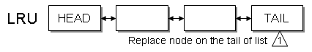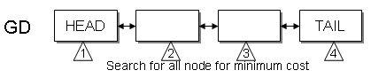
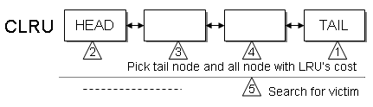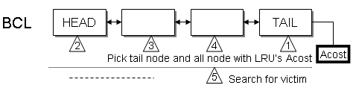
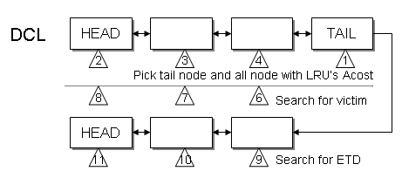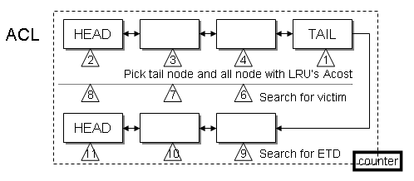
Figure 8. Implementation structures
On BCL, every thing is same except Acost. When LRU block is replaced, it uses Acost. We made ETD similar to cache structures and use it when miss happens. Last, in ACL we make counter but increase threshold to 5 which paper uses 1. Only one makes us not to use reservation on most cases. We tested and increased it.

4.2 Configuration
We used three different benchmarks; MCF, APPLU, and SWIM. For each benchmark, we changed number of sets, block size and associativity. The following is the summary of our configuration.

Machine 0 (ORIG)
Unified L2 cache | 256KB, 4-way, 64 byte line, LRU replacement, 12-cycle latency, write-back
Machine 1 (GD)
Unified L2 cache | 256KB, 4-way, 64 byte line, Greedy dual replacement, 12-cycle latency, write-back
Machine 2 (CLRU)
Unified L2 cache | 256KB, 4-way, 64 byte line, Cost Sensitive LRU replacement, 12-cycle latency, write-back
Machine 3 (BCL)
Unified L2 cache | 256KB, 4-way, 64 byte line, Basic Cost LRU replacement, 12-cycle latency, write-back
Machine 4 (DCL)
Unified L2 cache | 256KB, 4-way, 64 byte line, Dynamic Cost LRU replacement, 12-cycle latency, write-back
Machine 5 (ACL)
Unified L2 cache | 256KB, 4-way, 64 byte line, Adaptive Cost LRU replacement, 12-cycle latency, write-back

5. Analysis
In case of Apple, it shows dramatic cost reduction.
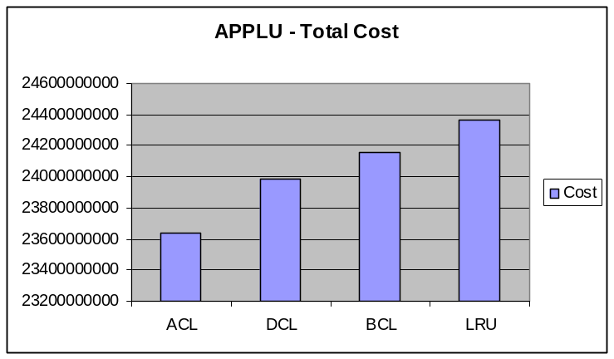
Figure 9. Comparison of cost
As a whole, considering only GD got very different cost result from considering cost and locality together.
5.1 Increase the number of sets
In case of MCF, change on set does not affect on results. But SWIM and APPLU shows very different result. Also DCL shows very poor performance. Normally miss rate is not so different between policies. Thus we can use cost concept without much penalty.
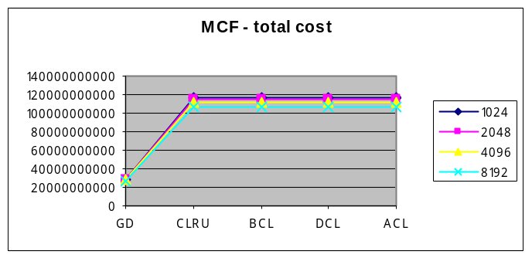 | 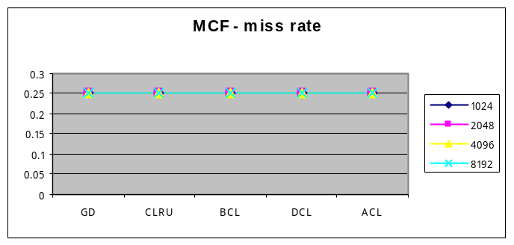
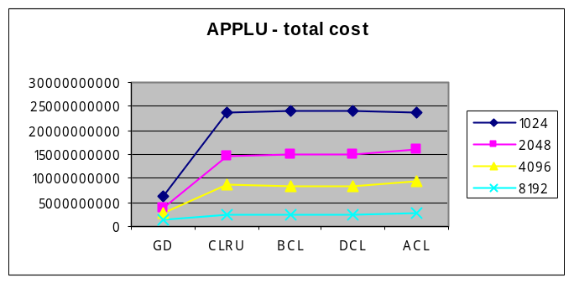 | 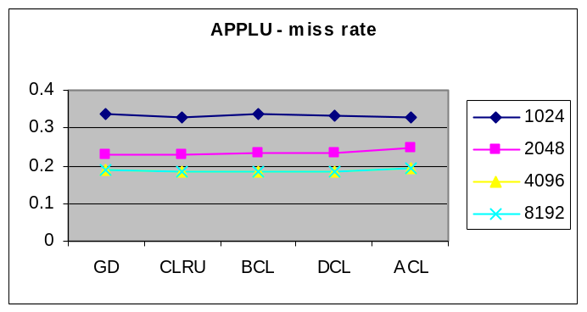
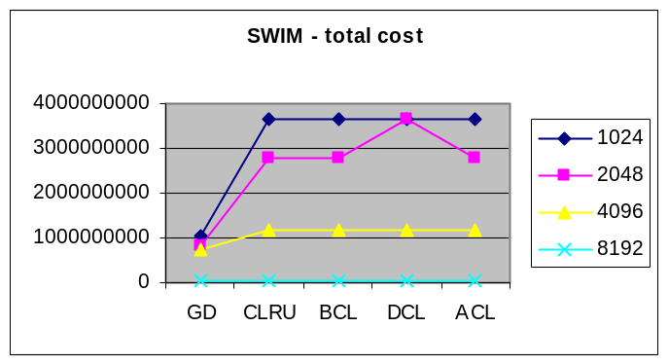 | 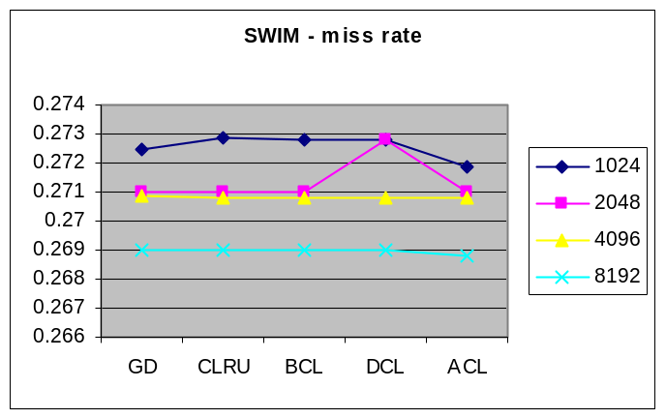

5.2 Increase the size of block
While increasing the size of block, the miss rate goes lower and cost also be reduced. GD has lowest miss rate.
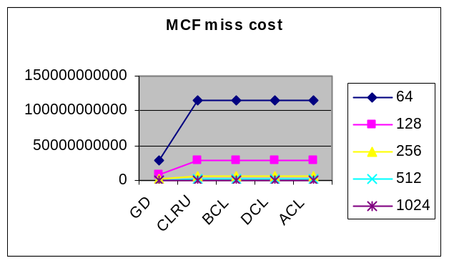 | 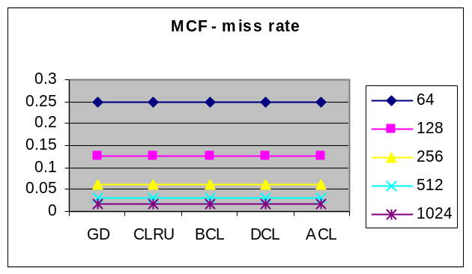
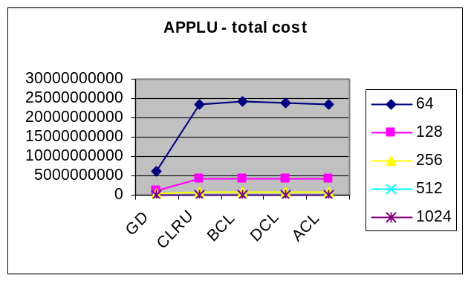 | 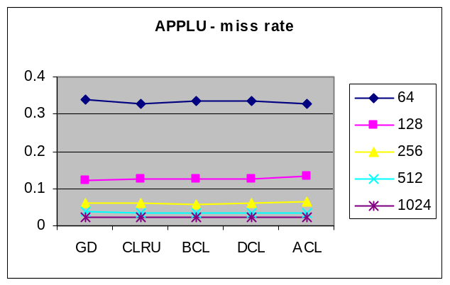
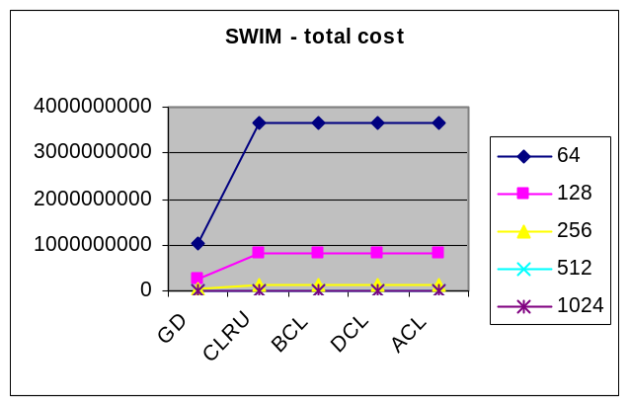 | 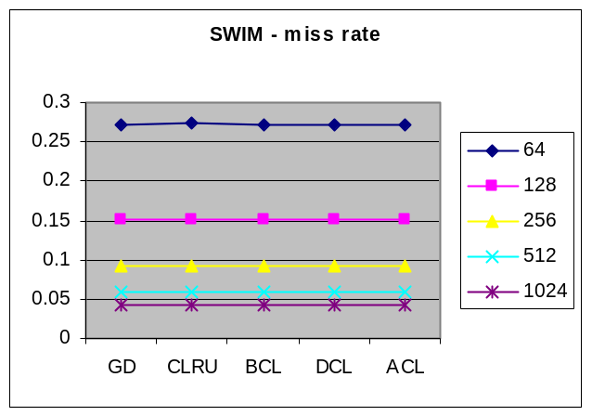
5.3 Increase the associativity
Increasing the associativity gives not so much difference until 4 but it changes a lot form 8. DCL also shows the poor performance.
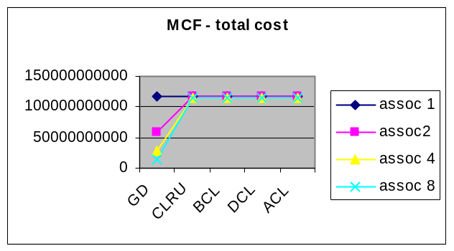 | 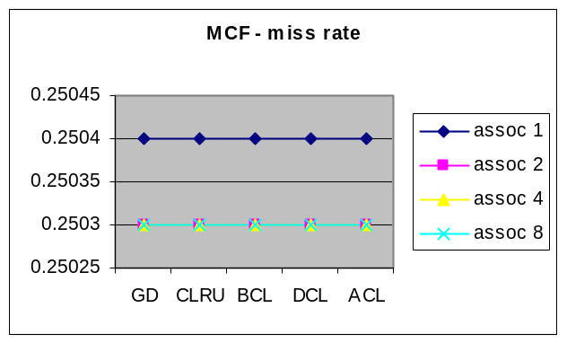
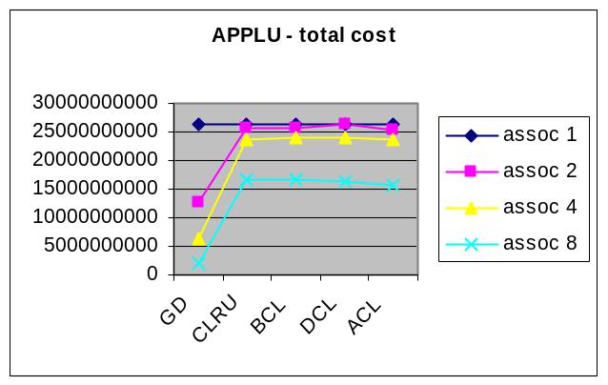 | 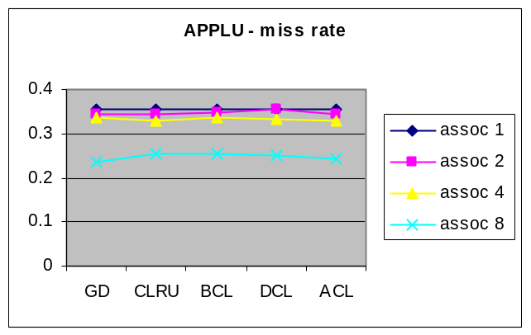
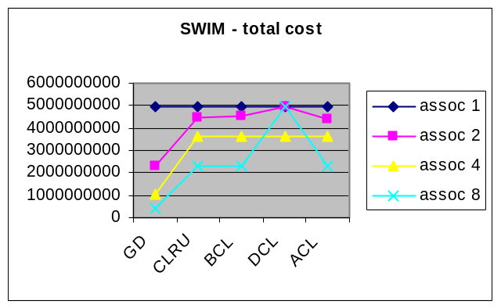 | 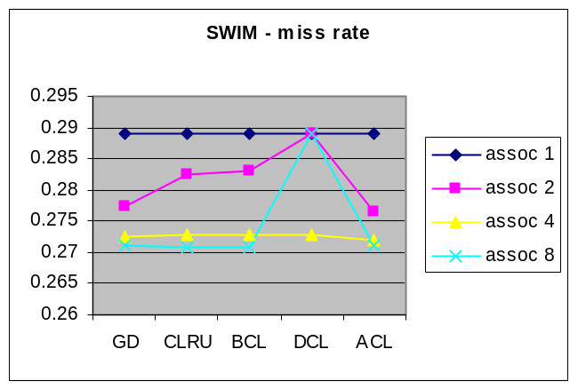

6. Conclusion
The reference paper asserts the importance of cost on cache replacement policy. Many replacement policies mostly considers the locality for minimize the cache miss but sometimes there is more big thing like power consumption. Although CPU work fast, high power consumption make system unstable and it may requires high cost on cooling or other thing. In this perspective, the referenced paper offers us new direction of research.
But we need to consider more about those algorithms. First, those complex algorithms may increase miss penalty for additional computational effort. Calculating cost and searching for lower cost is not simple job and may increase the overall CPI. But it is not considered and not simulated at this time. Second, concept of cost is still not clear. Although we understand that latency or power consumption could be the cost. We don’t know exactly how to define and calculate it. Last but not least, it is valuable only on multi processing environment. Although our future is multi-core, multi-CPU, majority of current machines use single core CPU. The future research should be done to solve these problems.

REFERENCES
- A. Gonzalez, C. Aliagas and M. Valero, “A Data Cache with Multiple Caching Strategies Tuned to Different Types of Locality,” In Proceedings of ACM International Conference on Supercomputing, July 1995.
- J. Chame and M. Dubois, “Cache Inclusion and Processor Sampling in Multiprocessor Simulations,” In Proceedings of ACM Sigmetrics, pp. 36-47, May 1993
- Multi-Core Technology, Advanced Micro Devices, Inc., http://multicore.amd.com/
- Intel® Pentium® Processor Extreme Edition 840 Datasheet, Intel Corporation,
http://www.intel.com/design/pentiumXE/datashts/306831.htm
- J. Jeong and M. Dubois, “Optimal Replacements in Caches with Two Miss Costs,” In Proceedings of 11th ACM Symposium on Parallel Algorithms and Architectures, pp. 155-164, June 1999.
- W. Wong and J. Baer, “Modified LRU Policies for Improving Second-Level Cache Behavior,” In Proceedings of the 6th International Symposium on High-Performance Computer Architecture, pp. 49-60, January 2000.

Appendix A. Increase number of set
A.1 Number of sets: 1024 & Block size: 64
MCF
Alg | Total Cost | CPI | IPC | miss rate
ORIG | 115984711769 | 0.4661 | 2.1457 | 0.2503
GD | 29128163698 | 0.4661 | 2.1457 | 0.2503
CLRU | 115984700007 | 0.466 | 2.1457 | 0.2503
BCL | 115983672387 | 0.466 | 2.1457 | 0.2503
DCL | 115984737039 | 0.466 | 2.1457 | 0.2503
ACL | 115984711769 | 0.4661 | 2.1457 | 0.2503

APPLU
Alg | Total Cost | CPI | IPC | miss rate
ORIG | 24369183794 | 0.6677 | 1.4977 | 0.3388
GD | 6195542944 | 0.668 | 1.497 | 0.3374
CLRU | 23622304696 | 0.6681 | 1.4968 | 0.3291
BCL | 24154837421 | 0.6681 | 1.4967 | 0.3361
DCL | 23982809429 | 0.6681 | 1.4967 | 0.3339
ACL | 23640651909 | 0.6677 | 1.4977 | 0.3292

Swim
Alg | Total Cost | CPI | IPC | miss rate
ORIG | 3642976270 | 0.562 | 1.7794 | 0.2713
GD | 1036929885 | 0.5621 | 1.7791 | 0.2725
CLRU | 3659786945 | 0.5622 | 1.7789 | 0.2729
BCL | 3662166703 | 0.5621 | 1.7789 | 0.2728
DCL | 3659222382 | 0.5621 | 1.7789 | 0.2728
ACL | 3653400641 | 0.5621 | 1.7792 | 0.2719

A.2 Number of sets: 2048 & Block size: 64
MCF
Alg | Total Cost | CPI | IPC | miss rate
ORIG | 114636902585 |  |  | 0.2503
GD | 28928740781 |  |  | 0.2503
CLRU | 114636563123 |  |  | 0.2503
BCL | 114635455811 |  |  | 0.2503
DCL | 114636599883 |  |  | 0.2503
ACL | 114636902585 |  |  | 0.2503

APPLU
Alg | Total Cost | CPI | IPC | miss rate
ORIG | 11470510981 |  |  | 0.1867
GD | 3926338484 |  |  | 0.2281
CLRU | 14748367282 |  |  | 0.23
BCL | 15038786205 |  |  | 0.2338
DCL | 14881661748 |  |  | 0.2317
ACL | 15969733424 |  |  | 0.2459

SWIM
Alg | Total Cost | CPI | IPC | miss rate
ORIG | 2780413676 |  |  | 0.2708
GD | 836462042 |  |  | 0.271
CLRU | 2776287415 |  |  | 0.271
BCL | 2778701292 |  |  | 0.271
DCL | 3659222382 |  |  | 0.2728
ACL | 2782692969 |  |  | 0.271

A.3 Number of sets: 4096 & Block size: 64
MCF
Alg | Total Cost | CPI | IPC | miss rate
ORIG | 111941480825 | 0.4661 | 2.1457 | 0.2503
GD | 28270629473 | 0.4661 | 2.1457 | 0.2503
CLRU | 111940485967 | 0.466 | 2.1457 | 0.2503
BCL | 111939996619 | 0.466 | 2.1457 | 0.2503
DCL | 111940522495 | 0.466 | 2.1457 | 0.2503
ACL | 111941480825 | 0.4661 | 2.1457 | 0.2503

APPLU
Alg | Total Cost | CPI | IPC | miss rate
ORIG | 7584784729 | 0.626 | 1.5976 | 0.1709
GD | 2751483201 | 0.6349 | 1.5751 | 0.1895
CLRU | 8632235408 | 0.6337 | 1.578 | 0.1848
BCL | 8440490397 | 0.6324 | 1.5813 | 0.1823
DCL | 8544242786 | 0.6332 | 1.5794 | 0.1837
ACL | 9287267830 | 0.6355 | 1.5737 | 0.1933

SWIM
Alg | Total Cost | CPI | IPC | miss rate
ORIG | 1167757367 | 0.5619 | 1.7796 | 0.2707
GD | 729230919 | 0.562 | 1.7795 | 0.2709
CLRU | 1161989197 | 0.5619 | 1.7795 | 0.2708
BCL | 1163158861 | 0.5619 | 1.7795 | 0.2708
DCL | 1161989197 | 0.5619 | 1.7795 | 0.2708
ACL | 1168484439 | 0.5619 | 1.7795 | 0.2708

A.4 Number of sets: 8192 & Block size: 64
MCF
Alg | Total Cost | CPI | IPC | miss rate
ORIG | 106551423737 | 0.4661 | 2.1457 | 0.2503
GD | 26955064994 | 0.4661 | 2.1457 | 0.2503
CLRU | 106550428815 | 0.466 | 2.1457 | 0.2503
BCL | 106549938251 | 0.466 | 2.1457 | 0.2503
DCL | 106550464783 | 0.466 | 2.1457 | 0.2503
ACL | 106551423737 | 0.4661 | 2.1457 | 0.2503

APPLU
Alg | Total Cost | CPI | IPC | miss rate
ORIG | 1939015128 | 0.6216 | 1.6088 | 0.1593
GD | 1323709124 | 0.6246 | 1.6011 | 0.1652
CLRU | 2381409751 | 0.6246 | 1.6011 | 0.1653
BCL | 2380798737 | 0.6245 | 1.6012 | 0.1653
DCL | 2381409751 | 0.6246 | 1.6011 | 0.1653
ACL | 2730074165 | 0.626 | 1.5975 | 0.1697

SWIM
Alg | Total Cost | CPI | IPC | miss rate
ORIG | 31887290 | 0.5619 | 1.7796 | 0.2688
GD | 26398413 | 0.5619 | 1.7795 | 0.269
CLRU | 32657050 | 0.5619 | 1.7795 | 0.269
BCL | 32714170 | 0.5619 | 1.7795 | 0.269
DCL | 32657050 | 0.5619 | 1.7795 | 0.269
ACL | 32083258 | 0.5619 | 1.7796 | 0.2688

Appendix B. Increase number of block size
B.1 Number of sets: 1024 & Block size: 64
MCF
Alg | Total Cost | CPI | IPC | miss rate
ORIG | 115984711769 | 0.4661 | 2.1457 | 0.2503
GD | 29128163698 | 0.4661 | 2.1457 | 0.2503
CLRU | 115984700007 | 0.466 | 2.1457 | 0.2503
BCL | 115983672387 | 0.466 | 2.1457 | 0.2503
DCL | 115984737039 | 0.466 | 2.1457 | 0.2503
ACL | 115984711769 | 0.4661 | 2.1457 | 0.2503

APPLU
Alg | Total Cost | CPI | IPC | miss rate
ORIG | 24369183794 | 0.6677 | 1.4977 | 0.3388
GD | 6195542944 | 0.668 | 1.497 | 0.3374
CLRU | 23622304696 | 0.6681 | 1.4968 | 0.3291
BCL | 24154837421 | 0.6681 | 1.4967 | 0.3361
DCL | 23982809429 | 0.6681 | 1.4967 | 0.3339
ACL | 23640651909 | 0.6677 | 1.4977 | 0.3292

SWIM
Alg | Total Cost | CPI | IPC | miss rate
ORIG | 3642976270 | 0.562 | 1.7794 | 0.2713
GD | 1036929885 | 0.5621 | 1.7791 | 0.2725
CLRU | 3659786945 | 0.5622 | 1.7789 | 0.2729
BCL | 3662166703 | 0.5621 | 1.7789 | 0.2728
DCL | 3659222382 | 0.5621 | 1.7789 | 0.2728
ACL | 3653400641 | 0.5621 | 1.7792 | 0.2719

B.2 Number of sets: 1024 & Block size: 128
MCF
Alg | Total Cost | CPI | IPC | miss rate
ORIG | 28676150847 | 0.4661 | 2.1452 | 0.1252
GD | 7234185207 | 0.4661 | 2.1452 | 0.1252
CLRU | 28676145145 | 0.4661 | 2.1452 | 0.1252
BCL | 28675455233 | 0.4661 | 2.1453 | 0.1252
DCL | 28676159909 | 0.4661 | 2.1452 | 0.1252
ACL | 28676150847 | 0.4661 | 2.1452 | 0.1252

APPLU
Alg | Total Cost | CPI | IPC | miss rate
ORIG | 3194689684 | 0.6297 | 1.588 | 0.102
GD | 1064578162 | 0.6438 | 1.5532 | 0.1232
CLRU | 4061010794 | 0.646 | 1.5479 | 0.1249
BCL | 4148599534 | 0.6467 | 1.5464 | 0.1272
DCL | 4094332446 | 0.6462 | 1.5476 | 0.1258
ACL | 4351880468 | 0.6489 | 1.5411 | 0.1325

SWIM
Alg | Total Cost | CPI | IPC | miss rate
ORIG | 813360418 | 0.562 | 1.7794 | 0.1516
GD | 240604488 | 0.562 | 1.7793 | 0.1517
CLRU | 811882012 | 0.562 | 1.7793 | 0.1517
BCL | 813031858 | 0.562 | 1.7793 | 0.1517
DCL | 811910584 | 0.562 | 1.7793 | 0.1517
ACL | 813302828 | 0.562 | 1.7794 | 0.1516

B.3 Number of sets: 1024 & Block size: 256
MCF
Alg | Total Cost | CPI | IPC | miss rate
ORIG | 7005592619 | 0.4664 | 2.1442 | 0.0627
GD | 1768863665 | 0.4664 | 2.1442 | 0.0627
CLRU | 7005425919 | 0.4664 | 2.1442 | 0.0627
BCL | 7005297563 | 0.4664 | 2.1443 | 0.0627
DCL | 7005431303 | 0.4664 | 2.1442 | 0.0627
ACL | 7005592619 | 0.4664 | 2.1442 | 0.0627

APPLU
Alg | Total Cost | CPI | IPC | miss rate
ORIG | 760426220 | 1.5788 | 1.5788 | 0.0578
GD | 240025794 | 1.5653 | 1.5653 | 0.0612
CLRU | 814564748 | 1.5669 | 1.5669 | 0.0607
BCL | 778752842 | 1.5742 | 1.5742 | 0.0589
DCL | 792553183 | 1.5713 | 1.5713 | 0.0596
ACL | 859636313 | 1.559 | 1.559 | 0.0631

SWIM
Alg | Total Cost | CPI | IPC | miss rate
ORIG | 126165271 | 0.5625 | 1.7777 | 0.0912
GD | 64162142 | 0.5626 | 1.7776 | 0.0913
CLRU | 125593937 | 0.5625 | 1.7778 | 0.0912
BCL | 125815593 | 0.5625 | 1.7777 | 0.0912
DCL | 125596985 | 0.5625 | 1.7777 | 0.0912
ACL | 126134133 | 0.5625 | 1.7777 | 0.0912

B.4 Number of sets: 1024 & Block size: 512
MCF
Alg | Total Cost | CPI | IPC | miss rate
ORIG | 1669291341 | 0.4669 | 2.1416 | 0.0314
GD | 422768673 | 0.4669 | 2.1416 | 0.0314
CLRU | 1669207983 | 0.4669 | 2.1416 | 0.0314
BCL | 1668979651 | 0.4669 | 2.1419 | 0.0314
DCL | 1669210123 | 0.4669 | 2.1416 | 0.0314
ACL | 1669291341 | 0.4669 | 2.1416 | 0.0314

APPLU
Alg | Total Cost | CPI | IPC | miss rate
ORIG | 169005126 | 0.6341 | 1.577 | 0.0356
GD | 60024460 | 0.6372 | 1.5693 | 0.0364
CLRU | 171991948 | 0.6357 | 1.5732 | 0.0359
BCL | 167147983 | 0.6342 | 1.5768 | 0.0354
DCL | 170893257 | 0.6353 | 1.574 | 0.0358
ACL | 173497892 | 0.6355 | 1.5736 | 0.036

SWIM
Alg | Total Cost | CPI | IPC | miss rate
ORIG | 5195087 | 0.5633 | 1.7753 | 0.0581
GD | 3872295 | 0.5633 | 1.7752 | 0.0582
CLRU | 5310467 | 0.5633 | 1.7752 | 0.0582
BCL | 5323227 | 0.5633 | 1.7752 | 0.0582
DCL | 5310467 | 0.5633 | 1.7752 | 0.0582
ACL | 5281275 | 0.5633 | 1.7753 | 0.0582

B.5 Number of sets: 1024 & Block size: 1024
MCF
Alg | Total Cost | CPI | IPC | miss rate
ORIG | 375417143 | 0.4671 | 2.1407 | 0.0157
GD | 105065324 | 0.4674 | 2.1397 | 0.0157
CLRU | 375694981 | 0.4675 | 2.1392 | 0.0157
BCL | 375655793 | 0.4674 | 2.1394 | 0.0157
DCL | 375695221 | 0.4675 | 2.1392 | 0.0157
ACL | 375601463 | 0.4673 | 2.1398 | 0.0157

APPLU
Alg | Total Cost | CPI | IPC | miss rate
ORIG | 32790744 | 0.6311 | 1.5846 | 0.0234
GD | 13896366 | 0.6326 | 1.5809 | 0.0235
CLRU | 32967814 | 0.6319 | 1.5826 | 0.0235
BCL | 32807108 | 0.6317 | 1.583 | 0.0234
DCL | 32967842 | 0.6319 | 1.5826 | 0.0235
ACL | 33201120 | 0.6315 | 1.5834 | 0.0235

SWIM
Alg | Total Cost | CPI | IPC | miss rate
ORIG | 131080 | 0.5644 | 1.7717 | 0.0421
GD | 112632 | 0.5644 | 1.7717 | 0.0421
CLRU | 131064 | 0.5644 | 1.7717 | 0.0421
BCL | 131180 | 0.5644 | 1.7717 | 0.0421
DCL | 131064 | 0.5644 | 1.7717 | 0.0421
ACL | 114680 | 0.5644 | 1.7718 | 0.0421

Appendix C. Increase number of Associativity
C.1 Number of sets: 1024 & Block size: 64 & Assoc: 1
MCF
Alg | Total Cost | CPI | IPC | miss rate
ORIG | 117026597904 | 0.4661 | 2.1455 | 0.2504
GD | 117026597904 | 0.4661 | 2.1455 | 0.2504
CLRU | 117026597904 | 0.4661 | 2.1455 | 0.2504
BCL | 117026597904 | 0.4661 | 2.1455 | 0.2504
DCL | 117026597904 | 0.4661 | 2.1455 | 0.2504
ACL | 117026597904 | 0.4661 | 2.1455 | 0.2504

APPLU
Alg | Total Cost | CPI | IPC | miss rate
ORIG | 26455591224 | 0.6713 | 1.4896 | 0.3533
GD | 26455591224 | 0.6713 | 1.4896 | 0.3533
CLRU | 26455591224 | 0.6713 | 1.4896 | 0.3533
BCL | 26455591224 | 0.6713 | 1.4896 | 0.3533
DCL | 26455591224 | 0.6713 | 1.4896 | 0.3533
ACL | 26455591224 | 0.6713 | 1.4896 | 0.3533

SWIM
Alg | Total Cost | CPI | IPC | miss rate
ORIG | 4965452600 | 0.5633 | 1.7751 | 0.289
GD | 4965452600 | 0.5633 | 1.7751 | 0.289
CLRU | 4965452600 | 0.5633 | 1.7751 | 0.289
BCL | 4965452600 | 0.5633 | 1.7751 | 0.289
DCL | 4965452600 | 0.5633 | 1.7751 | 0.289
ACL | 4965452600 | 0.5633 | 1.7751 | 0.289

C.2 Number of sets: 1024 & Block size: 64 & Assoc: 2
MCF
Alg | Total Cost | CPI | IPC | miss rate
ORIG | 116661819463 | 0.4661 | 2.1456 | 0.2503
GD | 58403002752 | 0.4661 | 2.1456 | 0.2503
CLRU | 116660398691 | 0.4661 | 2.1456 | 0.2503
BCL | 116666650725 | 0.4661 | 2.1457 | 0.2503
DCL | 116662341899 | 0.4661 | 2.1456 | 0.2503
ACL | 116661819463 | 0.4661 | 2.1456 | 0.2503

APPLU
Alg | Total Cost | CPI | IPC | miss rate
ORIG | 25206385234 | 0.668 | 1.4971 | 0.341
GD | 12773072863 | 0.6687 | 1.4954 | 0.3434
CLRU | 25522063565 | 0.671 | 1.4902 | 0.3456
BCL | 25603412170 | 0.671 | 1.4902 | 0.3466
DCL | 26455591224 | 0.6713 | 1.4896 | 0.3533
ACL | 25393400693 | 0.6688 | 1.4951 | 0.3435

SWIM
Alg | Total Cost | CPI | IPC | miss rate
ORIG | 4392633691 | 0.5623 | 1.7785 | 0.2755
GD | 2293806173 | 0.5625 | 1.7778 | 0.2774
CLRU | 4498735534 | 0.563 | 1.7763 | 0.2824
BCL | 4512924365 | 0.563 | 1.7762 | 0.2831
DCL | 4965452600 | 0.5633 | 1.7751 | 0.289
ACL | 4407256710 | 0.5624 | 1.7781 | 0.2764

C.3 Number of sets: 1024 & Block size: 64 & Assoc: 4
MCF
Alg | Total Cost | CPI | IPC | miss rate
ORIG | 115984711769 | 0.4661 | 2.1457 | 0.2503
GD | 29128163698 | 0.4661 | 2.1457 | 0.2503
CLRU | 115984700007 | 0.466 | 2.1457 | 0.2503
BCL | 115983672387 | 0.466 | 2.1457 | 0.2503
DCL | 115984737039 | 0.466 | 2.1457 | 0.2503
ACL | 115984711769 | 0.4661 | 2.1457 | 0.2503

APPLU
Alg | Total Cost | CPI | IPC | miss rate
ORIG | 24369183794 | 0.6677 | 1.4977 | 0.3388
GD | 6195542944 | 0.668 | 1.497 | 0.3374
CLRU | 23622304696 | 0.6681 | 1.4968 | 0.3291
BCL | 24154837421 | 0.6681 | 1.4967 | 0.3361
DCL | 23982809429 | 0.6681 | 1.4967 | 0.3339
ACL | 23640651909 | 0.6677 | 1.4977 | 0.3292

SWIM
Alg | Total Cost | CPI | IPC | miss rate
ORIG | 3642976270 | 0.562 | 1.7794 | 0.2713
GD | 1036929885 | 0.5621 | 1.7791 | 0.2725
CLRU | 3659786945 | 0.5622 | 1.7789 | 0.2729
BCL | 3662166703 | 0.5621 | 1.7789 | 0.2728
DCL | 3659222382 | 0.5621 | 1.7789 | 0.2728
ACL | 3653400641 | 0.5621 | 1.7792 | 0.2719

C.4 Number of sets: 1024 & Block size: 64 & Assoc: 8
MCF
Alg | Total Cost | CPI | IPC | miss rate
ORIG | 114636902585 | 0.4661 | 2.1457 | 0.2503
GD | 14459508960 | 0.4661 | 2.1457 | 0.2503
CLRU | 114636890807 | 0.466 | 2.1457 | 0.2503
BCL | 114635862819 | 0.466 | 2.1457 | 0.2503
DCL | 114636927839 | 0.466 | 2.1457 | 0.2503
ACL | 114637557949 | 0.4661 | 2.1457 | 0.2503

APPLU
Alg | Total Cost | CPI | IPC | miss rate
ORIG | 11300550012 | 0.6287 | 1.5906 | 0.1844
GD | 2071926744 | 0.6472 | 1.5451 | 0.2346
CLRU | 16516915541 | 0.6514 | 1.5352 | 0.2533
BCL | 16559989318 | 0.6505 | 1.5374 | 0.2538
DCL | 16417812823 | 0.6506 | 1.537 | 0.2519
ACL | 15832799575 | 0.65 | 1.5385 | 0.2441

SWIM
Alg | Total Cost | CPI | IPC | miss rate
ORIG | 2282381319 | 0.5619 | 1.7795 | 0.2707
GD | 420659992 | 0.562 | 1.7794 | 0.271
CLRU | 2274797227 | 0.562 | 1.7795 | 0.2709
BCL | 2277955311 | 0.562 | 1.7795 | 0.2709
DCL | 4965452600 | 0.5633 | 1.7751 | 0.289
ACL | 2286440539 | 0.562 | 1.7794 | 0.271

